

**Assignment – 3**

**Module – 3 Testing on Live Application**

1. What is RDBMS

Answer: Relational database management system (RDBMS) is a database management system (DBMS) that is based on the relational model as introduced by E. F. Codd.

1. What is SQL

Answer: SQL is Structured Query Language, which is a computer language for storing, manipulating and retrieving data stored in relational database

1. Write SQL Commands

Answer:

**DDL** – Data Definition Language

**DML** – Data Manipulation Language

**DCL** – Data Control Language

**DQL** – Data Query Language

1. What is join

Answer:

* A join is an SQL operation performed to establish a connection between two or more database tables based on matching columns, thereby creating a relationship between the tables.
* Most complex queries in an SQL database management system involve join commands.
* SQL Join statement is used to combine data or rows from two or more tables based on a common field between them.

1. Write type of joins.

Answer: Different types of Joins are as follows:

1. INNER JOIN
2. LEFT JOIN
3. RIGHT JOIN
4. FULL JOIN
5. **INNER JOIN:** Returns records that have matching values in both tables

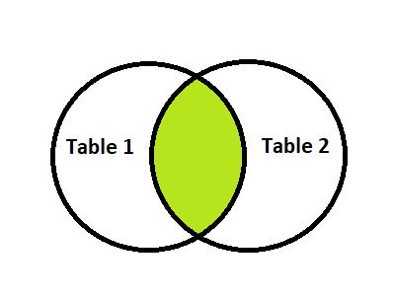

1. **LEFT JOIN:** Returns all records from the left table, and the matched records from the right table

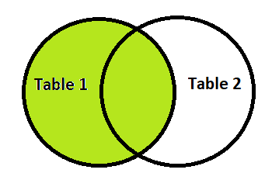

1. **RIGHT JOIN:** Returns all records from the right table, and the matched records from the left table

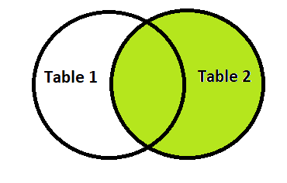

1. **FULL JOIN:** Returns all records when there is a match in either left or right table

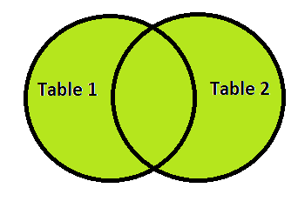

1. How Many constraint and describes it self.

Answer:

Not Full: Ensure that a column cannot have a null value.

Unique: Ensure that all values in a column are different.

Primary Key: A combination of a not null and unique.

Foreign Key: Prevents actions that would destroy links between tables.

Check: ensure that the values in a column if no value is specified.

Default: Sets a default value for a column if no value is specified.

Creat Index: Used to creat and retrieve data from the database very quickly.

1. Difference between RDBMS vs DBMS

Answer:

|  |  |
| --- | --- |
| RDBMS | DBMS |
| Data stored is in table format | Data stored is in the file format |
| Multiple data elements are accessible together | Individual access of data elements |
| Data in the form of a table are linked together | No connection between data |
| Normalisation is not achievable | There is normalisation |
| Support distributed database | No support for distributed database |
| Data is stored in a large amount | Data stored is a small quantity |
| Here, redundancy of data is reduced with the help of key and indexes in RDBMS | Data redundancy is common |
| RDBMS supports multiple users | DBMS supports a single user |
| It features multiple layers of security while handling data | There is only low security while handling data |
| The software and hardware requirements are higher | The software and hardware requirements are low |

1. What is API Testing?

Answer: Application Programming Interface (API) is a software interface that allows two applications to interact with each other without any user intervention. API (Application Programming Interface) is a computing interface which enables communication and data exchange between two separate software systems.

In API Testing, instead of using standard user inputs(keyboard) and outputs, you use software to send calls to the API, get output, and note down the system’s response.

1. What is API Testing?

Answer:

Open APIs:

These types of APIs are publicly available to use like OAuth APIs from Google. It has also not given any restriction to use them. So, they are also known as Public APIs.

Partner APIs:

Specific rights or licenses to access this type of API because they are not available to the public.

Internal APIs:

Internal or private. These APIs are developed by companies to use in their internal systems. It helps you to enhance the productivity of your teams.

1. What is Responsive Testing?

Answer:

A responsive web design involves creating a flexible web page that is accessible from any device, starting from a mobile phone to a tablet.

Furthermore, a responsive web design improves users’ browsing experience. Considering this from a quality assurance perspective, a responsive web design requires thorough evaluation using a variety of devices before it is ready to go live.

Software testers may find it challenging to perform responsive design testing as a variety of factors are to be looked into during the testing phase.

1. Which types of tools are available for Responsive Testing

Answer:

LT Browser, Lembda Testing, Google Resizer, Pixel tuner.

1. What is the full form of .ipa, .apk

Answer:

IPA: Internatonal Phonetic Alphabet.

APK: Android application package

1. How to create step for to open the developer option mode ON?

Answer:

About phone- developer option - USB debugging- USB debugging mode, press ok.